**FIFO**

**Program**

#include<stdio.h>

void main() {

int i, j, k, f, pf=0, count=0, rs[25], m[10], n;

printf("\n Enter the length of reference string :");

scanf("%d",&n);

printf("\n Enter the reference string : ");

for(i=0;i<n;i++)

scanf("%d",&rs[i]);

printf("\n Enter no. of frames : ");

scanf("%d",&f);

for(i=0;i<f;i++)

m[i]=-1;

printf("\n The Page Replacement Process is : \n");

for(i=0;i<n;i++)

{

for(k=0;k<f;k++)

{

if(m[k]==rs[i])

break;

}

if(k==f)

{

m[count++]=rs[i];

pf++;

}

for(j=0;j<f;j++)

printf("\t%d",m[j]);

if(k==f)

printf("\n");

if(count==f)

count=0;

printf("\n The number of Page Faults using FIFO are %d",pf);

}

**Output**

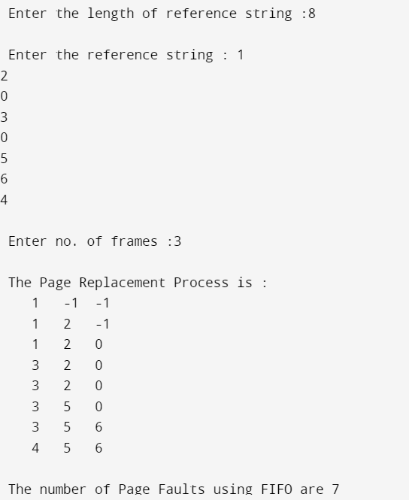

**LRU**

**Program**

#include<stdio.h>

void main()

{

int i,j,k,min,rs[25],m[10],count[10],flag[25],n,f,pf=0,next=0;

printf("Enter the length of the reference string :");

scanf("%d",&n);

printf("Enter the reference string : ");

for(i=0;i<n;i++)

{

scanf("%d",&rs[i]);

flag[i]=0;

}

printf("Enter the number of frames :");

scanf("%d",&f);

for(i=0;i<f;i++)

{

count[i]=0;

m[i]=-1;

}

printf("\nThe Page Replacement process is : \n");

for(i=0;i<n;i++)

{

for(j=0;j<f;j++)

{

if(m[j]==rs[i])

{

flag[i]=1;

count[j]=next;

next++;

}

}

if(flag[i]==0)

{

if(i<f)

{

m[i]=rs[i];

count[i]=next;

next++;

}

else

{

min=0;

for(j=0;j<f;j++)

if(count[min] > count[j])

min=j;

m[min]=rs[i];

count[min]=next;

next++;

}

pf++;

}

for(j=0;j<f;j++)

printf("%d\t",m[j]);

printf("\n");

}

printf("\nThe number of page faults using LRU are: %d",pf);

}

**Output**

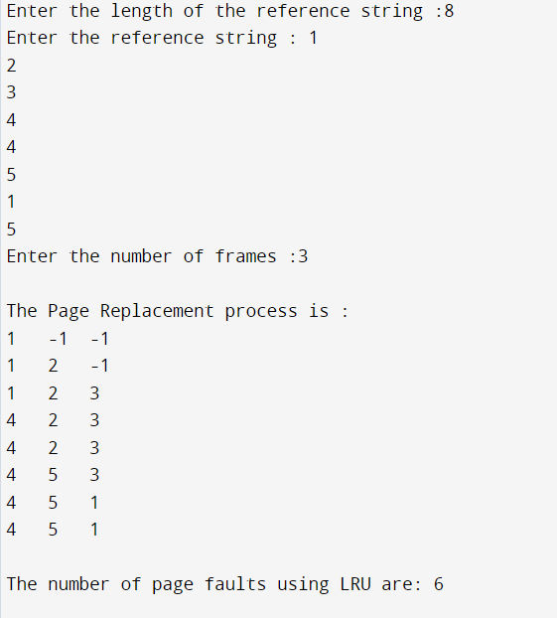

**LFU**

**Program**

#include<stdio.h>

void main()

{

int rs[50], i, j, k, m, f, count[20], a[20], min, pf=0;

printf("\nEnter number of page references : ");

scanf("%d",&m);

printf("\nEnter the reference string :");

for(i=0;i<m;i++)

scanf("%d",&rs[i]);

printf("\nEnter the available no. of frames : ");

scanf("%d",&f);

for(i=0;i<f;i++)

{

count[i]=0;

a[i]=-1;

}

printf("\nThe Page Replacement Process is: \n");

for(i=0;i<m;i++)

{

for(j=0;j<f;j++)

if(rs[i]==a[j])

{

count[j]++;

break;

}

if(j==f)

{ min = 0;

for(k=1;k<f;k++)

if(count[k]<count[min])

min=k;

a[min]=rs[i];

count[min]=1;

pf++;

}

printf("\n");

for(j=0;j<f;j++)

printf("\t%d",a[j]);

}

printf("\n\nTotal number of page faults :%d",pf);

}

**Output**

